IMPAL

**LAPORAN**

CYCLOMATIC COMPLEXITY

garis horizontal

# 

## Function Input mobil

public function car_input()

{

$var['facility_data'] = $this->mfacility->load_data();

$var['troom_data'] = $this->mtroom->load_data();

$this->load->view('admin/part/bus/input', $var);

}

Cyclomatic Complexity = 2

**Function Delete Mobil**

public function car_delete($id)

{

$do_del = $this->mbus->delete_data($id);

echo $do_del;

}

Cyclomatic Complexity = 2

**Function Update Mobil**

Cyclomatic Complexity = 2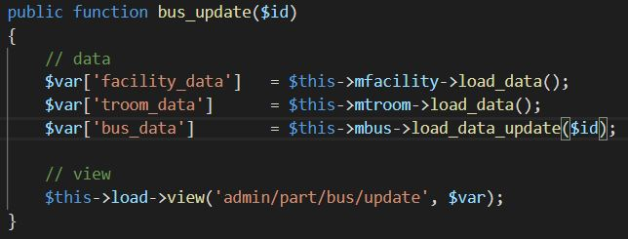

**Function Save Edit Data Mobil**

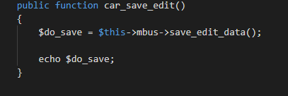

Cyclomatic Complexity = 2

**Function Index**

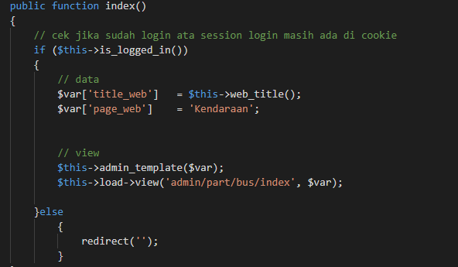

Cyclomatic Complexity = 2-1+2 = 3